**Introduction**

*Problem Statement:*

A lot of people dont have access to internet and a way to charge their devices while outside.

Motivation:

To provide power to charge devices and wifi to people in an underdeveloped community who use public transport and amenities and reduce the digital gap

*Requirements*

1. Uses solar energy to charge devices: Critical

This target is essential to the project. This is the primary purpose of building the device. Metric is binary as it only needs to use solar power per customer instructions.

1. The device will not break under a Cat 3 Hurricane:

This target is important for the safety and well-being of the people and the device. The metric was taken from the requirements of the Florida Building Code. The only limit to resistance would be the cost and not being able to be permanently fixed.

The device will be constructed with materials certified to be resistant and put under pressure simulating a Cat 3 Hurricane.

1. Will not be permanently attached:

This target aims to make the device movable to any place that is needed without it being destroyed. This is a goal but can be dismissed if incompatible with the previous target.

1. Provides WiFi to a Small Area:

This target is moderately important as it is a soft requirement and can be adjusted depending on price and power consumption. The ideal value comes from other market alternatives, which puts this product on par with many other repeaters. We will measure the broadcast of the network at different points more than 600m away from the device to see the reach.

1. Components are accessible and replaceable:

This target aims to facilitate the interchange of pieces and the replacement of faulty equipment in the device. It also helps the long-term goal of modularity in the device. All pieces that need to be replaced at some point should be easily accessible to a crew without complete disassembly.

1. Will use a battery to store power: Critical

This target’s goal is to make the device usable even without constant sun at any given time. The battery should last at least 6 hours. 14 hours is the lowest amount of time without sunlight in Tallahassee recorded between 2021-2022.

The battery will be timed from fully charged until total depletion and should be more than 6hrs.

**Selected Concept**

Our final concept uses two 12v crystalline solar panels in parallel which sends dc power through the charge controller to the battery. Thus the battery provides power the the wifi repeater through the dc-dc converter and provides power to the ports through the micro controller which regulates the power output.

**Preliminary Design**

*Project Block Diagram:*

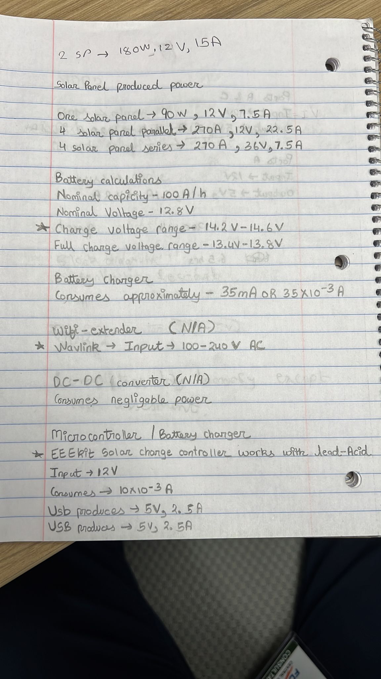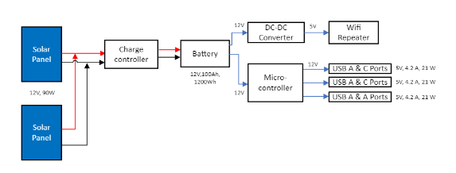

*Calculations:*

*Functional Decomposition Changes:*

During our functional decomposition, our diagrams were very broad and basic. Our newer design provides more detail on how we implement the solar umbrella, along with displaying the compatibility of power and voltage between each of the blocks.

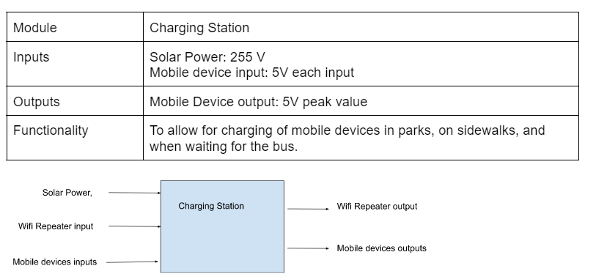

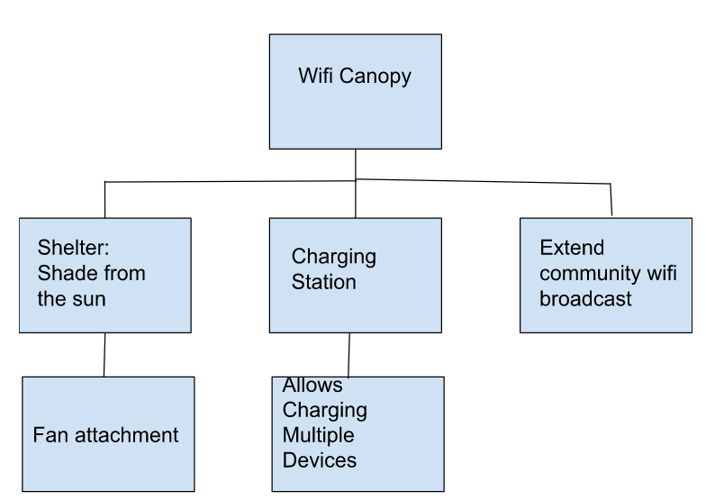

**Summary**

The design went though various changes based on compatibility and affordability. With theses obstacles limiting our design we made a new design that would fit into the budget, would be power compatible, and meet all requirements. For instance, we change from an alkaline battery to lithium ion because of its charge time along with compatibility with the crystalline solar panels. We added a dc-dc converter because the wifi repeater requires ac power so the power had to be changed. The charge controller controls the flow of electricity to the battery. As mentioned before the micro controller regulates the power output to the usb ports.