Customer Matrix

|  | Requirements | Output Power | Installation Time | Efficiency | Wifi Range | Weather Reisitant |
| --- | --- | --- | --- | --- | --- | --- |
| Needs |  | + | - | + | + | + |
| Power | + | ↑↑ |  | ↑↑ | ↓↓ |  |
| Durable | + |  |  |  |  | ↑↑ |
| Movable | + | ↓ | ↑ |  |  | ↓↓ |
| Maintainable | + |  | ↑↑ |  |  | ↓ |
| Wifi | + | ↓ |  |  | ↑↑ |  |
| Reliable | + | ↓ |  | ↑↑ | ↑↑ |  |

Engineering Matrix

|  |  | Output Power | Installation Time | Efficiency | Wifi Range | Weather Reisitant |
| --- | --- | --- | --- | --- | --- | --- |
|  |  | + | - | + | + | + |
| Output Power | + |  |  | ↑ | ↓ |  |
| Installation time | - |  |  |  |  | ↓ |
| Efficiency | + |  |  |  | ↑ | ↓ |
| Wifi Range | + |  |  |  |  |  |
| Weather Resistant | + |  |  |  |  |  |

House of Quality

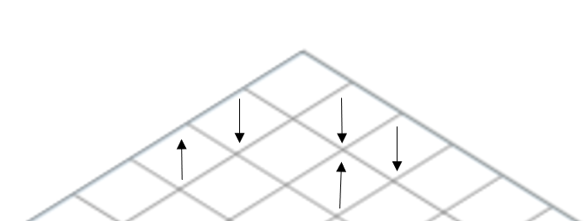

|  | Requirements | Output Power | Installation Time | Efficiency | Wifi Range | Weather Reisitant |
| --- | --- | --- | --- | --- | --- | --- |
| Needs |  | + | - | + | + | + |
| Power | + | ↑↑ |  | ↑↑ | ↓↓ |  |
| Durable | + |  |  |  |  | ↑↑ |
| Movable | + | ↓ | ↑ |  |  | ↓↓ |
| Maintainable | + |  | ↑↑ |  |  | ↓ |
| Wifi | + | ↓ |  |  | ↑↑ |  |
| Reliable | + | ↓ |  | ↑↑ | ↑↑ |  |
| Targets for Requirement |  | 250W | 4h | > 70% | 200m radius | Cat 3 hurricane |

Pugh Selection Matrix

| Weight | Option 1  (Baseline) | Option 2 | Option 3 | Option 4 |
| --- | --- | --- | --- | --- |
| Charge Duration 5 | - | +1 | +1 | -1 |
| Cost 2 | - | +1 | 0 | +1 |
| Size 1 | - | 0 | 0 | -1 |
| Wifi Range 4 | - | +1 | +1 | 0 |
| Score | - | 11 | 9 | -4 |
| Continue? | Combine | Yes | Combine | No |

Analytical Hierarchy Process (AHP)

|  | Charge Duration | Cost | Size | Wifi Range | Mean | Weights |
| --- | --- | --- | --- | --- | --- | --- |
| Charge Duration | 1 | 2 | 2 | 5 | 2.5 | 0.42 |
| Cost | 1/2 | 1 | 1 | 4 | 1.625 | 0.16 |
| Size | 1/2 | 1 | 1 | 1 | 0.875 | 0.10 |
| Wifi Range | 4 | 2 | 2 | 1 | 2.25 | 0.32 |

The chart compares the customer needs with the engineering requirements in Customer Tradeoff Matrix and compares the engineering requirements with themselves in the Engineering Tradeoff Matrix. In the bottom row of the House of Quality the targets for requirements are shown. For the output power the target for requirement in 250W. This number comes from the charging station and the Wi-Fi repeater power needed. The power is from solar panels and being stored in a battery. The next target requirement is the installation time. This is the time it will take to assemble and disassemble the solar umbrella which comes from the customer needs of maintainable and movable. The efficiency requirement comes from the reliability to maintain the able to charge devices and have Wi-Fi. The Wi-Fi range target requirement is to have a 200m radius from the Wi-Fi repeater. The weather resistant category comes from the customer needs of durable and reliable. The category 3 hurricane requirement comes from the Florida Building Code.