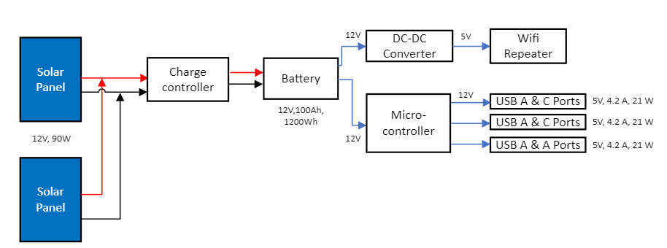

Introduction

The design can be split into two sections: the input and the output. The input consists of the solar panels, the solar charge controller and the battery. For the output it can be divided into two subsections based on their functions. The first subsection includes a DC-DC converter and a Wi-Fi repeater, while the second subsection contains USB A and C ports.

Solar Panels

The first selection needed is a solar panel, the other equipment required gets chosen based on the ratings from the selected solar panel. Four 60W polycrystalline solar panels were chosen for this design of a solar umbrella. A polycrystalline solar panel was selected over a monocrystalline panel because they are cheaper and the efficiency between them is only slightly different. The first step to figuring out how many panels are needed is to figure out how many Wh/day a single panel can produce. In order to find out how much power the panel can produce, the Global Horizontal Irradiance (GHI) of the area has to be known. As previously stated this solar umbrella is being designed for the Tallahassee area so, the GHI is 4.79kwh/m^2/day [3].

(2)

As seen in equation (1) the energy for a single 60W panel is 287.4Wh/day. To find out how many panels are needed to power the umbrella it is a simple calculation. It is found by dividing the answer from equation (1) by the answer from equation (2).

(3)

From equation (3) the answer found is 3.53 panels but because a half of a panel is not possible the only solution is to round up to 4.

There are two energy requirements for our design, a Wi-Fi extender and 4 USB outlets. The Wi-Fi extender draws 12.5 W, and the USB outlets will consume 96 W. Assuming the Wi-Fi extender will be running 24 hours a day and outlets will be running 5 hours a day we can conclude that the system will consume 780 Wh/day. This is calculated by multiplying the watts and hours for each output that is operating. Once the total amount of Wh/day is found it is then multiplied by 1.3 which is the standard rule for accounting for the safety margin if the irradiation is higher than normal. Irradiation is when an object is exposed to radiation.

(1)

In equation (1) the total Photovoltaic (PV) panel energy is found to be 1014Wh/day . Now that the energy requirement is calculated the equipment needed can be selected.

Battery

Now that the panels are chosen and how many are needed is selected, the battery size can be calculated. Before choosing between a lead acid battery or a lithium-ion battery the sizing has to be found. In order to sizing the battery, the total power for outputs and nominal voltage of the panel have to be known. The nominal voltage of the solar panel is 12V [4] and the total power for the outputs from the outlets and Wi-Fi extender is 120.5W.

(4)

From the calculation of equation (4) the battery size is found to be 12V and 90.4Ah. A 100Ah battery was selected because a 90.4Ah battery does not exist. With the battery size calculated a type of battery can be selected. For this type of design two battery types can be used either lead acid or lithium-ion. For the solar umbrella the lithium-ion battery is the better choice. This is because the lithium-ion has a higher energy density and is a deep cycle battery. A higher energy density means it can store more energy given the same amount of space and a deep cycle means that it can use almost all of its capacity. The lead acid battery is not a deep cycle battery, so it is not able to use the majority of its capacity. The lithium-ion battery is lighter, has a deep cycle, and has a higher energy density making it the ideal choice for the solar umbrella.

Solar Charge Controller

When making a PV solar system a solar charge controller is necessary. The solar charge controller connects the solar panels and the battery. The solar charge controller’s job is to make sure the battery can safely discharge and charge. This is done by controlling how much voltage can go to the battery at a time. For example, the battery chosen for this design is a 12V battery so a 12V solar charge controller is needed to make sure it doesn’t get more than 12V input into the battery. To select the right solar charge controller the current coming from the solar panels must not exceed the limit of the charge controller. In order to find out how much current is coming from the panels the short circuit current(Isc) must be known.

(5)

The equation above mentions 4 strings; this is the number of panels that are in parallel and the 1.3 is the safety margin if the irradiation is higher than normal. The equation shows that the amount of current going to the charge controller is 18.67A. There is another choice for the charge controllers once the current rating is found. There are two types of charge controllers: a pulse width modulation (PWM) and a maximum power point tracker (MPPT). A PWM controls how much voltage is going to the battery by sending a pulse of power to reduce the average amount of voltage going to the battery. The PWM charge controller is cheaper than the MPPT but less efficient. A MPPT charge controller works by calculating the maximum point the current can flow at a voltage the battery can handle. The MPPT has better efficiency and works better for larger systems. The 30A charge controller that is selected for this design is a PWM. The PWM charge controller was selected because the umbrella is a small system and as a cheaper option. In this design a 30A PWM charge controller was chosen. The PWM charge controller was selected because the umbrella is a small system and as a cheaper option.

Volt Converter

The DC-DC voltage converter was chosen to lower the voltage from the battery to the Wi-Fi repeater. It is used to convert the DC power from the solar panels and battery to DC power to power the WiFi converter. The input of the repeater is 5V and the battery outputs 12V.

Wifi Extender

The Wifi Extender has a voltage of 5V, current at 2.5A, power of 12.5W, and a data transfer rate of 1200 Mbps. This wifi extender was chosen because in was in the budget, has a repeater mode to boost the existing internet broadcast, and the range of the extender can reach up to 1000 sq feet at 2.4 GHz and 2800 sq feet at 5 GHz.

Ports

The ports in the design include USB A & USB C Outlets. The ports each have a voltage of 12V, current at 2.1A, power of 25.2W sourced directly from the battery. We chose USB A & C because these were most compatible with our design as these are more affordable, operate with the design power output, and are more convenient to implement.

Structure

The material selected for the umbrella structure was aluminum metal. This material was chosen based on the requirement for the structure to withstand the weather based on Florida Building Code. The Code requires buildings to hold up against a category 3 hurricane or to be easily taken apart. For this design the structure was chosen to be able to be disassembled but able to withstand mild weather.